Sub symbolic AI methods: Project 5

Solving Multi-Objective Traveling Salesman Problem using Evolutionary Algorithm

Bjørnar Walle Alvestad

2016

Norwegian University of Science and Technology



# Implementation and MOEA design

## Genotype

The genotype consists of a byte-array with length equal the number of cities in the traveling salesman problem (TSP). In this case, the length is 48, because this is a 48-city problem. The byte-array represents a sequence of city visits, where the number stored in the array reflects the city index. Because the byte-datatype can store a maximum value of 127, this is an upper limit of problem size. This can be increased by instead using the short- or int datatype. The byte datatype was chosen for increased performance.

## Phenotype

During phenotype evolution, the total cost and distance for the TSP route is calculated and stored in the phenotype. Also stored in the phenotype structure is the solution rank and crowding distance, which will be used in the selection strategy.

## Crossover and mutation operators

The crossover operator is implemented by first copying a sub-sequence of random length and start position from one of the parents. Then, the remaining elements are extracted from the other parent, in the same order as they appear. In order to avoid producing infeasible offspring, the mutation operator skips cities that are already present in the sequence, proceeding to the next one in the parent sequence until all entries has been filled.

The mutation operator swaps a random pair of entries in the genotype. Because entries are swapped, it is not possible for the mutation operator to produce infeasible solutions, if the sequence was feasible to begin with. This is because swapping only changes the order of city visitation, it can never remove or introduce a new city to the TSP route. During mutation, only a single pair of entries are swapped.

## Selection strategy

The selection strategy is the *Crowding Tournament Selection Operator* as described in the lecture [1] (page 63-64). First, 20 phenotypes are selected for a tournament. The winner is determined by comparing ranks and crowding distance, where lower rank and higher crowding distance is favorable. In a tournament with two individuals, the one with the lowest rank will win. If the rank of the two are equal, the one with the highest crowding distance is selected. Two tournament winners are selected for breeding with crossover and mutation.

When selecting solutions for the next generation, the best N solutions are selected, where N is the population size. The solutions are selected front-wise, beginning with the pareto front and then the next front, until N solutions have been selected. This selection operator will not select duplicate solutions; these are simply skipped. This selection strategy introduces elitism, because the best solutions are automatically carried over to the next generation. This ensures that a good solution is not lost during the EA run.

# EA choices

## Best combinations

Below is a table presenting the three best combination of the EA parameters. These are not average results for multiple runs, only one run was performed. This explains the relative big variance in the results for best and worst objective values.

|  |  |  |  |  |  |  |  |
| --- | --- | --- | --- | --- | --- | --- | --- |
|  | Population size: | Generations: | Crossover rate: | Mutation rate: | Best objectives: | Worst objectives: | Non-dominated solutions: |
| Case 1: | 200 | 20000 | 0.7 | 0.6 | Dist: **36132**  Cost: **319** | Dist: **107391**  Cost: **1706** | **217** |
| Case 2: | 1000 | 1000 | 0.9 | 0.8 | Dist: **39489**  Cost: **387** | Dist: **122558**  Cost: **1691** | **263** |
| Case 3: | 100 | 50000 | 0.95 | 0.7 | Dist: **37399**  Cost: **295** | Dist: **120232**  Cost: **1427** | **107** |

# Solution plots

## Population

Below are the results from the three combinations. The objective values for the entire population is presented, along with best and worst cases.

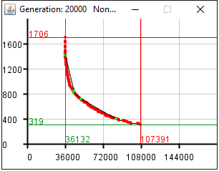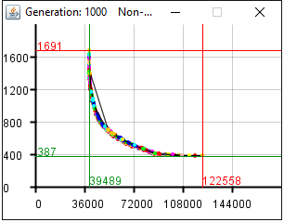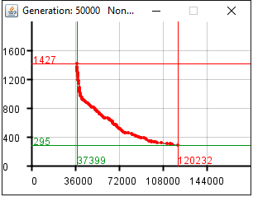

## Pareto-front

The following plots presents the objective values for the pareto front only. These plots originate from the same runs as the previous plots.

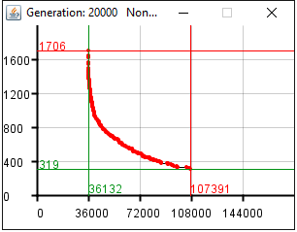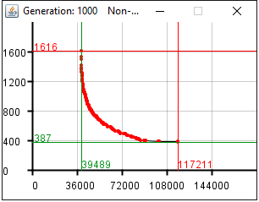

## Comparison

The following plot is a comparison of the pareto fronts of the three cases.  
Red = case 1  
Green = case 2  
Blue = case 3

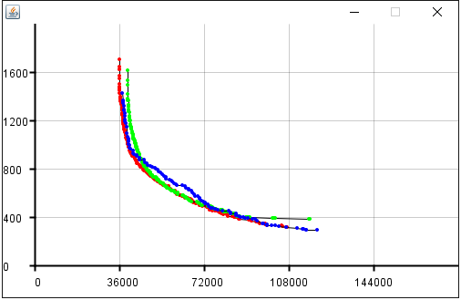

# References

1. Ripon, K. 2016. *Lecture 9 – Multi-Objective Evolutionary Algorithms*. IT3708 Sub-symbolic AI methods. 8 March, NTNU.